CHAPTER 7: Chemical reactions
Worksheet 7.3

Acids and bases
Science Quest 9: pages 262–7
Student: Class:
1. The following table shows the colours of common indicators in solutions of acids and bases. Complete the table for the common household materials.
Indicator | Acid colour | Base colour
Methyl orange | Red–orange | Yellow
Litmus | Red | Blue
Bromothymol blue | Yellow | Blue
Phenolphthalein | Colourless | Pink–crimson

Household material | Lemon juice | Baking powder | Ammonia | Lemonade
Methyl orange
Litmus
Bromothymol blue
Phenolphthalein
2. The diagram below shows some organs of our digestive system, including the typical pH of the liquids in the stomach and duodenum.
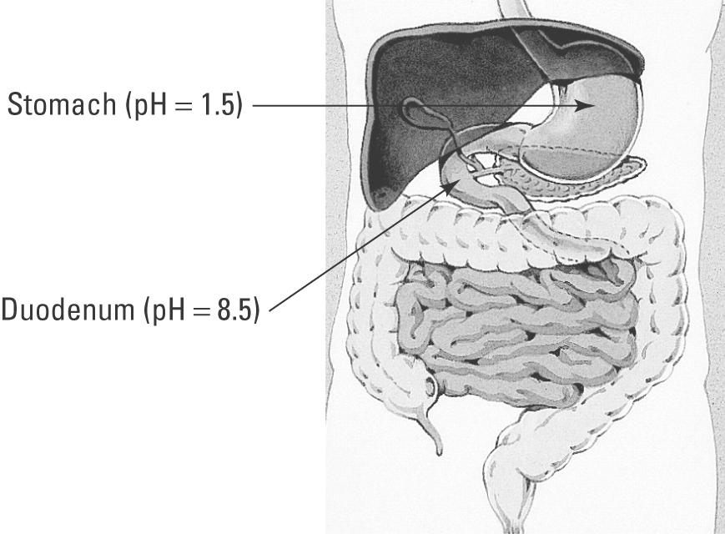
(a) What is the pH of neutral water?
(b) Explain why the pH rises as liquids move from the stomach into the duodenum.

3. A student adds 5 mL of diluted vinegar to a beaker, and then adds 5 drops of the selected indicator. Drops of household ammonia are then added one at a time while a glass rod is used to stir the mixture.
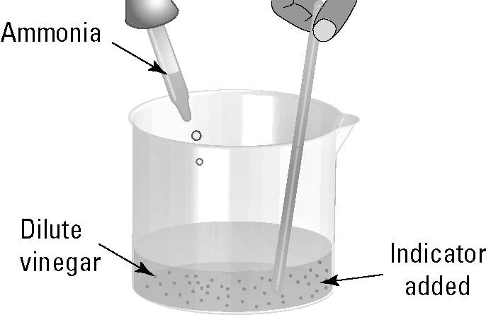
Describe the observations that would be made if each of the indicators below was used in separate experiments. Assume that an excess of ammonia is finally added to the beaker.
(a) Bromothymol blue:

(b) Phenolphthalein:

